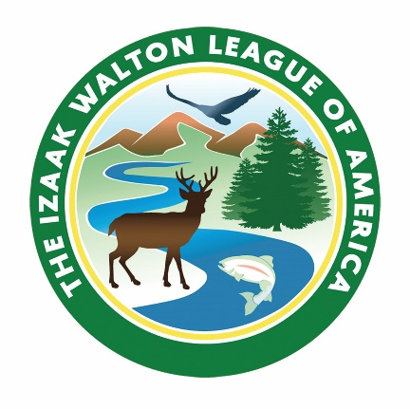
Digital Communications Manager
Izaak Walton League of America

Founded in 1922, the Izaak Walton League of America created the template for the modern environmental movement by combining grassroots activism, media savvy and powerful messages that helped form the nation’s bedrock conservation laws and policies. The League’s mission is to conserve, restore and promote the sustainable use and enjoyment of our natural resources, including soil, air, woods, waters and wildlife. Our members and staff combine hands-on conservation action, policy work with legislatures and resource agencies, and public education to pursue our conservation goals at the local, state and national levels.

SUMMARY OF POSITION
This position is responsible to day-to-day management of the League’s email, social media and website and provides writing, proofreading, research, fact-checking and other editorial support for the League’s digital and print communications, adhering to the League’s mission and strategic goals. Under strategic direction of Communications Director, the Digital Communications Manager will design, execute, and analyze digital advocacy campaigns to support specific initiatives, ensuring consistency with organizational objectives. This position allows for telework up to two days per week.

DUTIES AND RESPONSIBILITIES
- Serve as the primary manager of the League’s website, which includes but is not limited to developing and updating content across the site; collaborating with League program managers to ensure program-specific content is current, relevant and meets program-specific objectives; using analytics and other tools within the website CMS and email communications system to target content for specific visitors; and facilitating volunteer engagement, policy advocacy and online donations.
- Manage day-to-day production and distribution of the League’s email, social media and electronic newsletters.
- Create, execute and analyze digital advocacy campaigns supporting specific priorities consistent with the League’s mission and values.
- Develop and implement effective, interactive digital communications through the League’s social media channels (e.g. Instagram, Facebook, Youtube), website, video and electronic newsletters.
- Collaborate with the Director of Member Programs regarding on-going integration between CRM database and email and other electronic communication systems to ensure data integrity, facilitate segmented communication and address any technical issues affecting on-going integration of these systems.
- Write and edit content for League members, supporters and volunteers including for digital media and the League’s quarterly magazine, Outdoor America.
- Track and analyze metrics from digital communications and campaigns to assess and improve the effectiveness of League communications.
- Provide support to volunteer leaders at chapters and state divisions related to digital communications, social media and websites.
- With assistance from other staff members, develop a substantive understanding of conservation and outdoor recreation issues relevant to the League to effectively communicate with members and external audiences such as lawmakers and the media.

QUALIFICATIONS
- Demonstrated experience managing social media (e.g., Instagram, Facebook, YouTube).
- Demonstrated experience with website content management systems (such as WordPress, Drupal) and email communication systems (such as HubSpot). Experience using HubSpot is strongly preferred.
- Ability to integrate information in a membership database (such as iMIS) with email and other electronic communications systems for the purpose of audience segmentation, audience-specific communication, and list management and data integrity.
- Experience with video creation is preferred.
- Excellent written and verbal communication skills.
- Bachelor’s degree in communications, marketing or relevant field of study and 3 to 5 years of experience working on digital communications campaigns, social media and websites.
- Understanding of conservation and outdoor recreation issues preferred.
- Ability to work independently as well as collaboratively with League staff and members/volunteers.
- Well organized and detail oriented.
- A positive, professional, solutions-oriented attitude.
- Ability to travel (estimated to be not more than five percent of total time annually). Some meetings and events will require overnight stays and work during the evening and on weekends.

SALARY RANGE
$62,000 to $72,000, commensurate with experience.

TO APPLY
Send resume, cover letter and work samples of digital campaigns to info@iwla.org by May 15, 2025.

The Izaak Walton League of America is an
equal opportunity employer.

707 Conservation Lane
Gaithersburg, Md 20878
www.iwla.org
April 29, 2025

