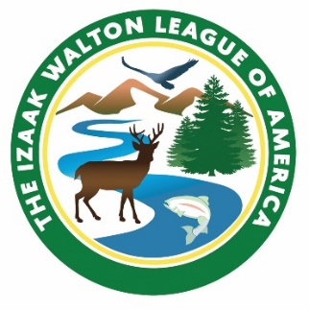
IWLA 501(c)(3) Compliance Check List

The League has developed this brief check list to help chapters and divisions track their submissions and to simplify the process of reporting when certain documents do not have to be submitted. Please use this form and include it when returning copies of the relevant information to the national office. Thank you.

Chapter / Division Name: __________________________________________ ____________________________________
Please check the appropriate response:

By-laws
□ Enclosed
□ Not amended since last submission
Date most recently amended _____________________
□ Yes □ No Has your chapter reviewed its by-laws in the past 5 years?

Articles of Incorporation
□ Enclosed
□ Not amended since last submission
Date most recently amended______________________

IRS Form 990, 990 EZ or 990 N Postcard
□ Enclosed
□ Extension requested (please enclose copy of request form and IRS approval)

State Corporate Filings for 2024
□ Enclosed
□ State filings not required

Proof of Insurance *
□ Certificate Enclosed
□ Chapter / Division does not own, rent, lease or use property for any purpose

Chapter / Division Questionnaire
□ Enclosed

