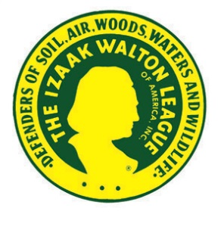
MEDIA ALERT
DATE

Izaak Walton League XX Chapter Is Working To Ensure
Clean Water for our Community

WHO: | XX Chapter of the Izaak Walton League of America
WHAT: | Monitoring Water Quality in Stream Name
WHEN and WHERE: | DATE and TIME of event  Starting Point for event (address) | General Directions to Starting Point (if necessary, such as to a specific spot in a park)
WHY: | XX stream is vital to the health of CITY/TOWN, flowing through our parks and neighborhoods and contributing to local drinking water supplies [IF APPLICABLE]. The critical question is: do local residents have the information they need about water quality in XX stream?  The XX Chapter of the Izaak Walton League is working to provide that information. Through a program called Save Our Streams (SOS), chapter members and other volunteers will test the water in XX stream – and share the results with the community.  The greatest threat to water quality today is polluted runoff from farm fields, parking lots, industrial sites, and yards across America. That runoff – much less visible than discharges from a factory pipe – flows unchecked and untreated into our streams and rivers. It carries animal waste, bacteria, cancer-causing chemicals, and countless other pollutants through our communities.  As sources of water pollution become more dispersed, the public has limited information about water quality in most local streams. According to the U.S. Environmental Protection Agency (EPA), 80 percent of streams nationwide are not assessed for pollution. And that’s only half the problem. Of the fraction of streams that are monitored, EPA reports that more than half do not meet basic safety standards for fishing, swimming, or as sources of drinking water.  Volunteer stream monitors provide the first line of defense for clean water, highlighting potential problems – and solutions – and providing local communities with the water quality information they deserve. The Izaak Walton League is working to empower more Americans to collect water quality information in local streams. Through the Clean Water Challenge, the League will mobilize and train volunteers to monitor 100,000 more stream sites across the country by 2022.
CONTACT: | Name  Chapter Office (if applicable)  Phone Number, E-mail

